1. **Purpose**

To ensure that Liquid product is produced and loaded properly and to ensure that all corresponding paperwork is filled out correct.

The Giles Liquid Loading System uses a mass flow meter for controlling the percent MgSO4 and the total weight of a liquid load. Most operator effort is making sure the hoses are connected to the proper place and the right information for the load is entered into the Monitoring System.

1. **Scope**

This procedure needs to be performed for each liquid product tanker loaded. This procedure applies to all liquid product tankers loaded from the Manufacturing facility.

1. **Responsibility**

All Manufacturing Lead Operators and Material handlers are responsible for this procedure.

1. **Safety Considerations**

* Safety shoes and safety glasses are required when working in the plant.
* Safety is a condition of employment. Employees are not authorized to work in an unsafe manner and are prohibited from harming the environment of the facility or community.
* Ensure all hoses and couplings are working because the Liquid Loading system uses compressed air to clean lines.

1. **Materials/Equipment**

* Monitoring System
* Pick Slip/Bill Of Lading
* Seal(s)

1. **Procedure**

**Data Entry**

1. Go to the “Liquid Load” screen on the Monitoring System
2. Click on “Operator Initials”, type in your initials, and press ENTER.
3. Click on “Load Number”, type in the load number, and press ENTER.
4. Click on “Percent MgSO4”, enter the percent using the popup, and click OK.
5. Click on “Load Weight (Pounds)”, enter the load weight in pounds, and click OK.

**Setup**

1. Ensure the small press is ready for use, the plates are aligned, and the Liquid Loading System control panel has the green “Ready” light on.
2. At the hydraulic unit, push the position valve away from the press, open the safety valve and press the paddle switch.
3. Pump the press up to 4000 psi.
4. Release the paddle and immediately close the blocking valve.
5. Ensure a hose is connected to the Liquid Load pump from the Brine Storage Tank.
6. Ensure a hose is connected from the Liquid Load pump to the Small Press Line.
7. Ensure a hose is connected from Small Press Line to the left side of the 3-way press valve.
8. Ensure small press valve is turned with yellow handle to the right.
9. Connect the hose to the load line.
10. Connect a hose from manual 3-way valve to the Mother Liquor Tank line (hose on right side).
11. Ensure 3-way valve is lined up to deliver the load waste to the Mother Liquor tank (valve handle in middle).
12. Ensure Load Hose is securely in the truck hatch and that the air valve is off, if equipped.

**Starting the Brine**

1. Open the valve on the Brine Storage Tank, to feed brine to the Liquid Load Pump.
2. If the Load is a 20% load, only open the Brine Storage Tank valve about half way.
3. Start the Liquid Load Pump.
4. Ensure the Water Control Valve and Blocking Valves are open.

**Loading**

1. When product is going through the system and bypassing to the Mother Liquor Tank, press the

green “Start Load” button on the Liquid Loading System control panel.

1. The Bypass Valve should shift to the Load Line and the “Loading” light should come on.
2. Watch the system for leaks, and verify the information on the Monitoring System is correct – it

can be changed while the load is in progress.

1. When the load is finished, an Alarm will sound and “Stop the Pump and Close the valve” light

will come on.

**Backwash**

1. Stop the Liquid Load Pump, and close the Brine Storage Tank Valve.
2. Presses “Start Wash” button on the Liquid Loading System control panel.
3. Press will automatically backwash until density drops, then it will blow out line to ML tank.
4. Wait until the “Ready” light comes on before getting ready for the next load.

**Finish**

1. Partially open the manual 3-way valve to relieve any pressure on the Mother Liquor line.
2. Drop the line to the Mother Liquor tank so any residual liquid can drain.
3. Drop the load line so it can drain any residual liquid.
4. Close the drain valve.
5. Relieve the pressure on the little press so it can drain by opening the blocking valve and turning

the handle to the opposite side on the hydraulic unit.

**Emergency Stop**

1. If for any reason, you need to stop the load, press the red “Manual Stop” button on the liquid

loading control panel.

1. Continue the backwash sequence starting at step 26.

**Paper Work**

1. When a driver shows up for a load, find the corresponding Bill Of Lading (BOL) that matches the pick-up number out of the BOL box and use the "Truck Loading Time" stamp, stamp the top sheet (pick slip) of the BOL and then use the time clock to clock the driver in beside "Truck Arrived".
2. Once the driver is in the loading station take the BOL to the driver, show the driver the amount and weight of the order. Have the driver initial beside pick up number stating it is the correct number and ship to location.
3. Before loading, inspect the tanker. If the tanker has noticeable amount of dirt or build up it cannot be loaded with Giles product. Driver should be instructed to leave and come back with a clean tanker. Note dispute on BOL cover sheet for future reference.
4. On the "Truck Loading Time" stamp, use the time clock to clock the driver in beside "Start".
5. Trucks are to be loaded according to the loading chart on page 2 of this procedure.
6. If the truck is not present during loading, jack stands much be placed under the trailer while loading.
7. While loading the tanker, it needs to be inspected 5 times during loading – ( beginning, ¼, ½, ,¾ & end )
8. Fill out a corresponding Certificate of Analyses (C of A) to be sent with the load.
9. After the tanker is loaded, on the Pick Slip the loader signs and dates and clocks the driver out using the time clock beside the "Finish" section of the "Truck Loading Time" stamp. Both the Loader and the Driver must initial loading times stating when the truck arrived and when it was finished loading.
10. On the BOL the loader writes down Trailer number in vehicle number slot. The Lot number and the Seal number are to be written in the center section. The loader should then sign, date and put the time loading and paper work was completed in the designated area at the bottom of the BOL. Have the driver sign and date in designated area. Keep the top copy for the office. Give the driver the second copy. Staple the third copy of the BOL with a Certificate of Analysis and any other customer required paper work together for the truck driver.
11. Sign off the load on Liquid Load Board and place finished paper work in the BOL box ready for office pick up.

PICK SLIP

The Pick slip is the top sheet of a Bill of Lading or BOL. The Pick Slip is generated by the Customer Service Department when a Customer places and order. This is a quick reference of the BOL and customer order, this is information telling the loader what material and what amount the customer has ordered.

1. Get Pick up number from driver, compare number to Loading Board. Then find the corresponding BOL and Pick sheet.
2. Have Driver initial beside the Pick Up number on the pick slip.
3. Clock Driver in when they arrive and before you start loading and when finished
4. Check Product code and Amount needed.
5. Check off what location you are shipping the product from.
6. Check the percentage to be loaded and SCR number before loading product. Sign off stating you have checked everything and it is acceptable.
7. SCR code is the Special Customer Requirements for the customer.

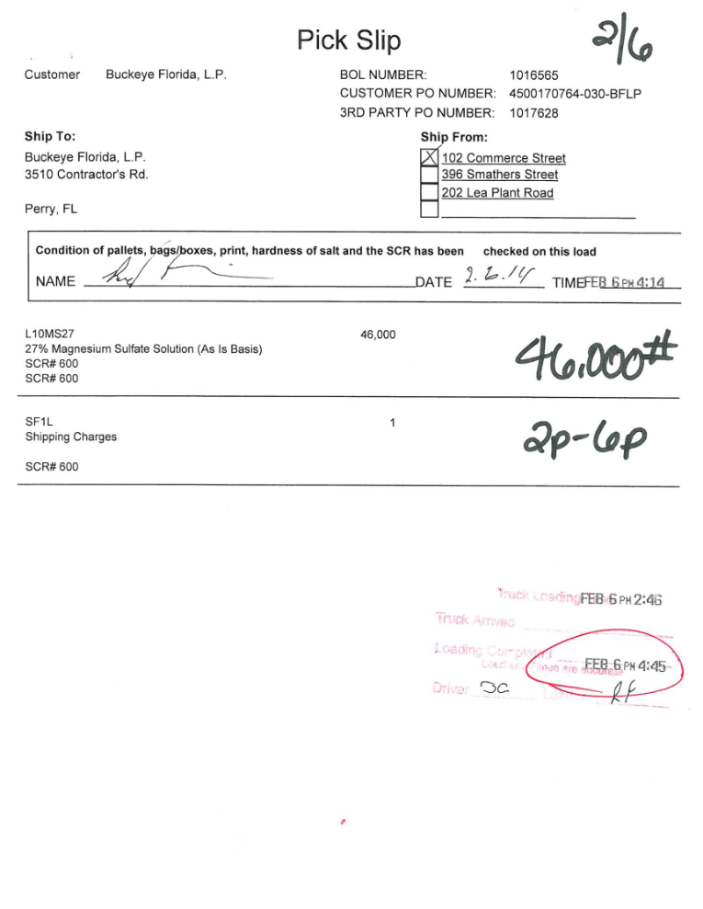  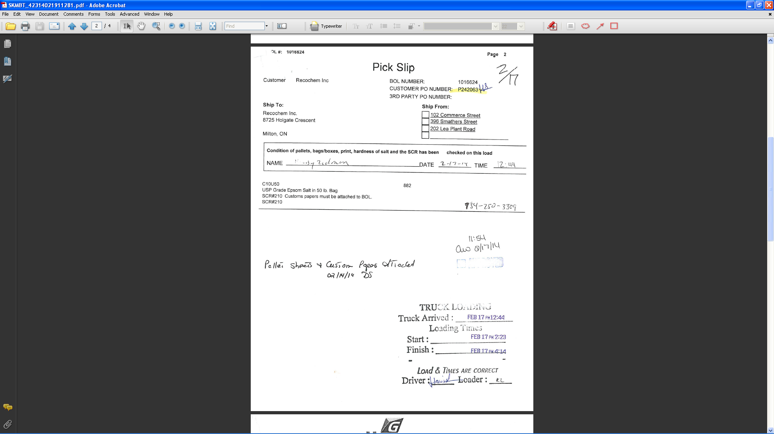

Drivers Phone Number

Check(s) while loading

When Tanker Arrived

When you started loading

When you finished loading

Driver and Loader initials

STRAIGHT BILL OF LADING

The Bill of Lading is generated by the Customer Service Department when a Customer places and order. Just like the Pick sheet, this is key information telling the loader what material and what amount the customer has ordered as well as ship to location. There are three copies of the bill of lading, one for the office, one for the driver and the last one to be attached to the COA and any other customer paperwork and sent with the driver.

1. Before Loading, check BOL for amount and product description.
2. Double check Pick Up number and Shipping Location.
3. Loader fills in
   1. Vehicle Number
   2. Lot Number
   3. Seal Number
4. When you have completed load, Sign BOL with Date and 24:00 hour time.
5. Disperse the 3 copies of completed BOL
   1. Keep top copy
   2. Driver gets 2nd Copy
   3. Staple the 3rd copy to the COA and any other customer paperwork together for the truck driver.

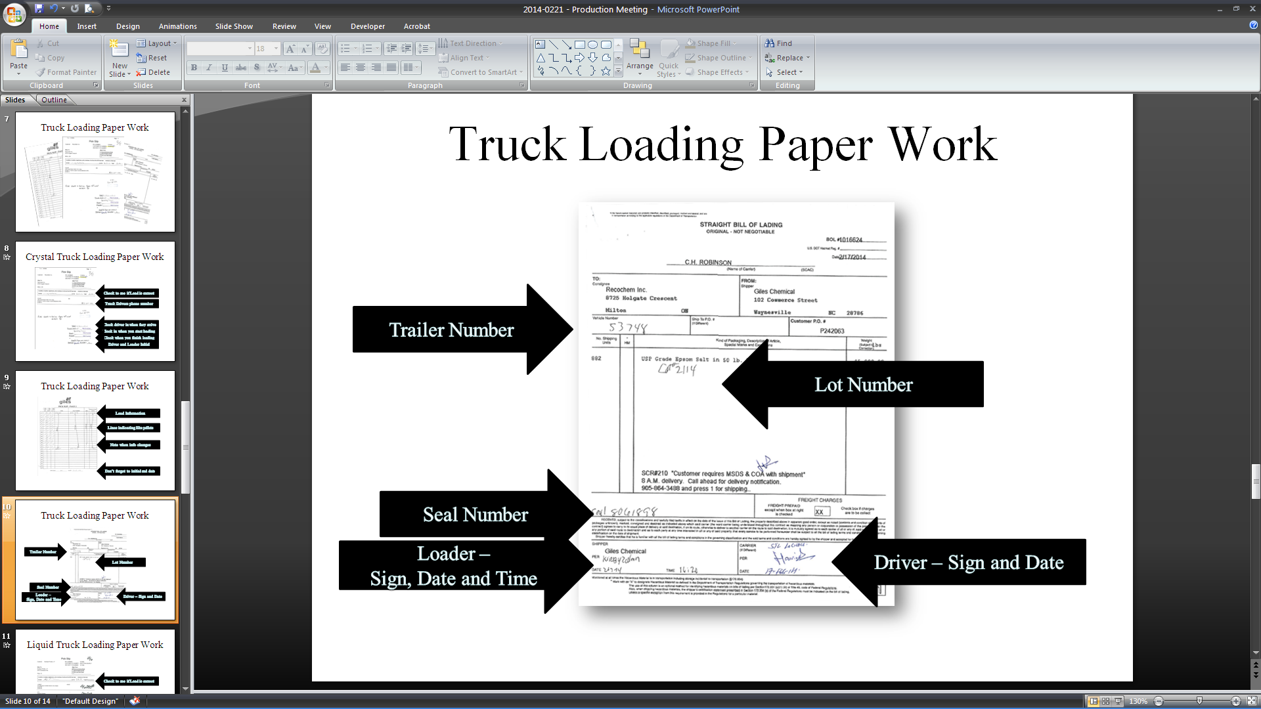

1. **Reference Documents**

N/A

1. **Change Information**

New Procedure